**L02 – Exploring Deep Learning Tools**

**Reflective Journal**

**Overview**

The purpose of this lab was to interact with and familiarize myself with a pre-trained deep learning model. I was meant to learn the components of the model, as well as how it makes predictions based on new data. Then I had to look at its behaviors and gain an understanding of how sensitive it was to different input data.

**Description**

For this lab I used Google Colab to run the model, and began running and examining the code within the cells. It started by importing some libraries before loading up the model, and along with some conversion and preprocessing, it let me input an image. I uploaded a simple image of a dog in a field of flowers as my test, and then used widgets to test changes to the image, I flipped it sideways, upside down, and added noise as a few different tests to see the results.

**Reflection**

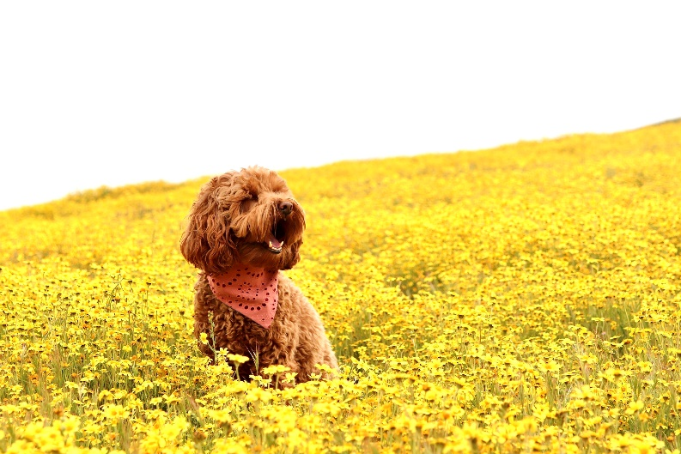When I first ran the model I didn’t expect how specific it would try to be, using this image as reference for prediction.

It tried to name the exact breed of dog, and the type of plant in the environment. Although it wasn’t completely accurate, as it guessed an Irish Water Spaniel which looks similar, it’s not exact. It also guessed the environment as a bunch of hay rather than flowers, I expected the predictions to be way more broad such as “field” “dog”. But on the next few uploads and slight changes it kept guessing different dog breeds.

When I got to experiment with image changes on the widgets, I didn’t see much change at all from just flipping the image around. But when I began adding noise to the image it started to get more confused, and eventually started seeing a cliff. Even more noise kept decreasing the accuracy more and more despite it looking relatively the same.

**Conclusion/Assessment**

This lab reminded me that AI Models still have a different process of interpreting what they see and how they respond compared to people. Even though it’s trying to mimic human thought or decipher what it’s seeing, they still struggle to look at whole images rather than specific parts and putting it together. While a human can pick up on a dog and it’s breed, an AI may not even be able to see a dog or see something completely different with just a little bit of noise added on.

I’ve also really begun to see how much AI has moved just from my first courses I took last year. The first model I used was more simplistic, identifying what I expected like “dog” “field”, but this one went straight into guessing specific breeds, vegetation, environment, and it’s all contained in an easy resource. This lab was a nice reminder on how these models are structured, and the steps images go through for processing into predictable data.